

A Unique Agency Offering:
- Recreational, leisure, and exciting day habilitation activities for adults
- Non-medical transportation
- Level One and IO Waiver Medicaid Services
- Supportive Living Services
- Respite

*These services are currently available for individuals enrolled on the IO or Level One Medicaid Waiver.
Steve & Mary Beha
- They reside with their son, Matthew, who has a developmental disability and a vision impairment.
- Steve has served individuals with developmental disabilities at an ICFMR (3 years); in Athens County (10 years); and at Carleton School and Meigs Industries in Meigs County (16 years).
- Steve & Mary have volunteered with Special Olympics for over 15 years.
- Mary has provided homemaker/personal care services through Level One and IO Waiver Services, and Supported Living.
- Proud parents of 5 children.

Expanding YOUR Horizons Executive Directors
Expanding YOUR Horizons
Expanding YOUR Horizons, LLC
34107 SR 681
Albany, Ohio 45710

740.416.1103

www.EYHservices.com

info@eyhservices.com

For additional information,
or to enroll in
Expanding YOUR Horizons’
Day Hab Program,
contact Steve & Mary:

Expanding YOUR Horizons, LLC
34107 SR 681
Albany, Ohio 45710

740.416.1103

www.EYHservices.com

info@eyhservices.com

Serving children and adults with developmental disabilities and their families throughout southeast Ohio.

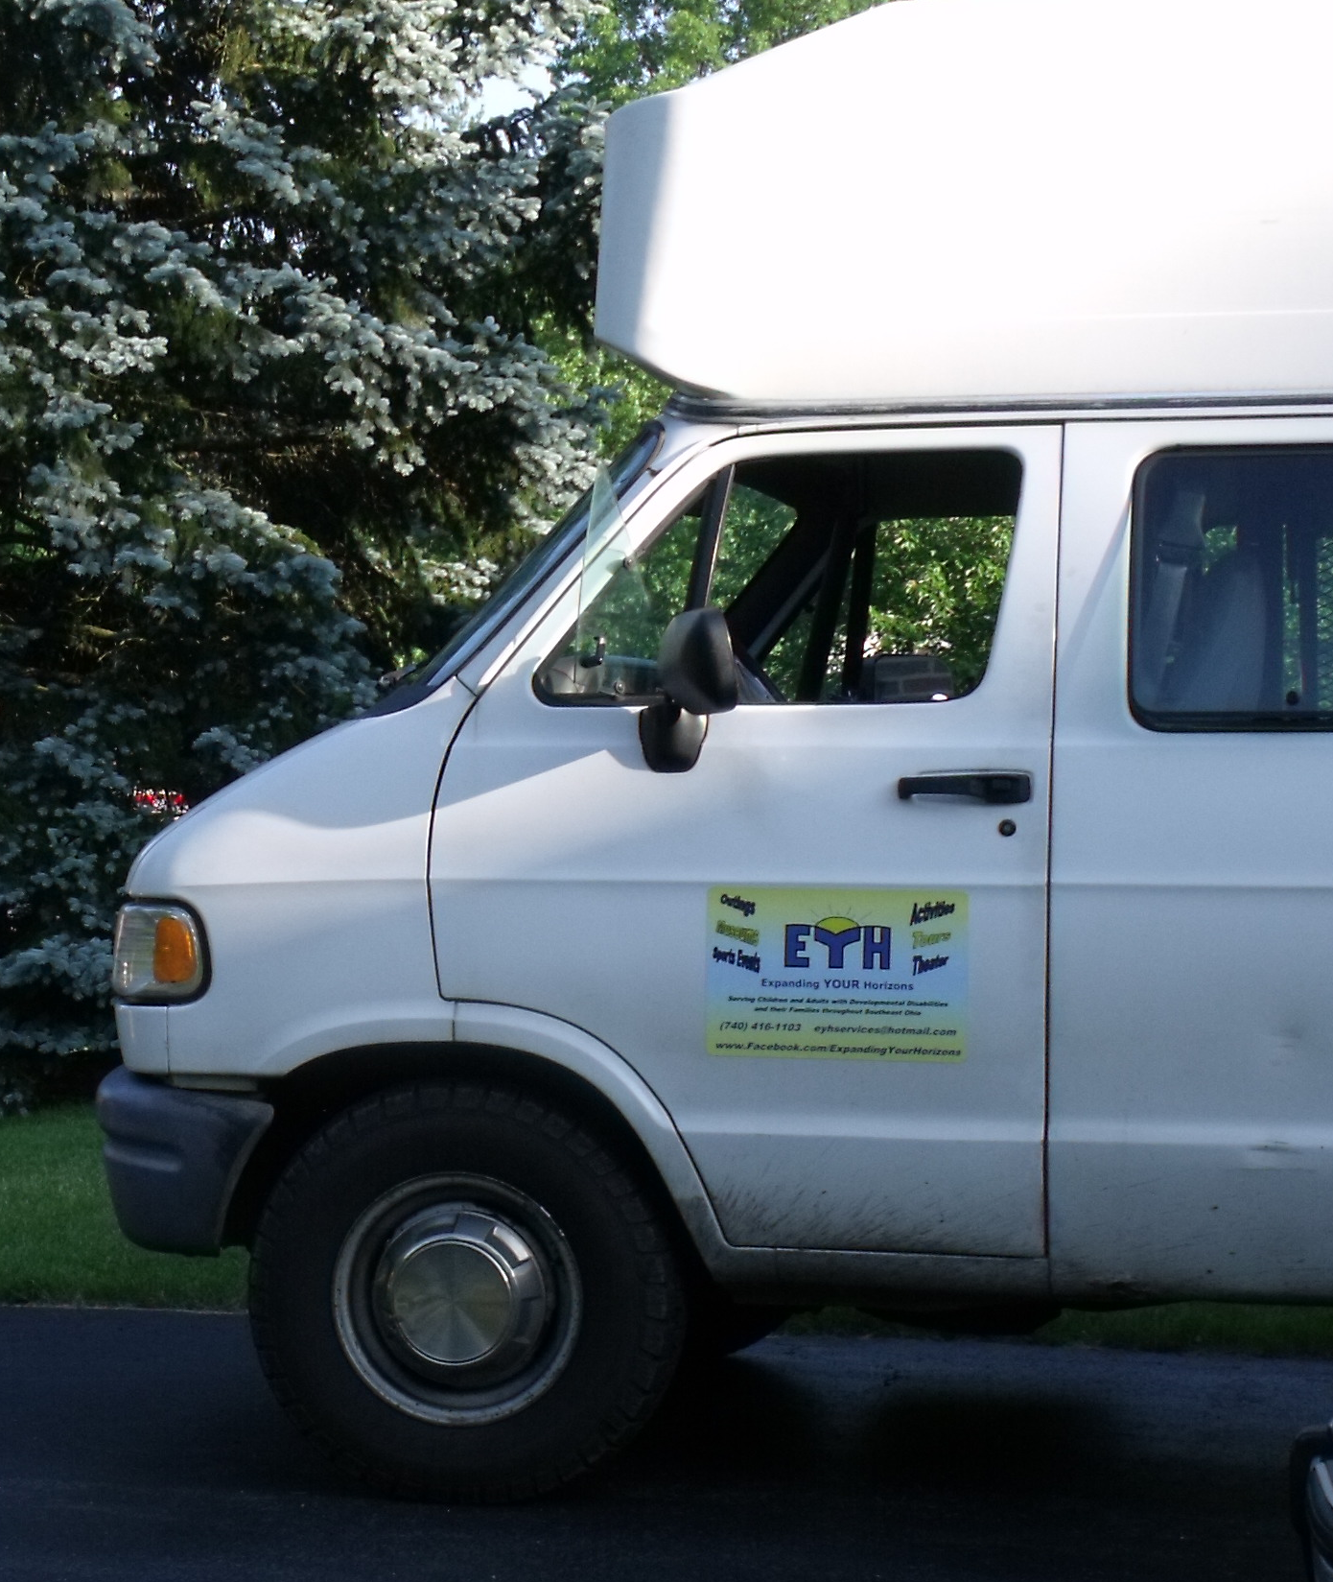
“Day Hab” FACTS
You may attend more than one day hab program. For instance, you could attend your county dd day hab program 3 days a week and another day hab program 2 days a week.
Day hab can take place during the day, in the evening, and on the weekend.
The maximum number of days you may attend all day hab programs in one year is 240 days.
Day hab does not have to take place in the county in which you reside.
Your County Board SSA will assist you in signing up with the day hab programs of your choice.
Activities ( Sternwheel Ride, Water Parks, Birthday Parties, Boating)
Events ( Plays, Concerts, Circus, Ice Capades)
Outings ( Blennerhassett Island, Columbus Zoo, Amish Country, Aquarium, Restaurants/Shopping/Movies)

**Individuals are responsible for their costs related to meals, event admission fees, and souvenirs**

Expanding YOUR Horizons: Providing A Unique Exciting Day Hab Program for Residents of Southeast Ohio

Expanding YOUR Horizons is committed to meeting the individualized needs and desires of individuals and their families.

Our program promotes self-esteem, self-determination, independence and choice through activities which offer skill development, independence, and community inclusion.

Examples of goals an individual may wish to focus upon include: safety skills within the community, utilizing community resources, shopping skills, appropriate public behavior, ordering from a menu, money skills, appropriate utilization of leisure time, decision making, and educational goals.
Day Hab That Is:

- Personal: We pick you up at your home, transport you to the activity in which you will be participating, and then return you to your home.

- Flexible: Choose from daily to weekly to monthly activities.

- Therapeutic: Focused on YOUR ISP goals.

- Exciting: Possible activities may include (to name a few):

Sporting Events ( Cincinnati Reds, Columbus Clippers, Ohio University, Ohio State Buckeyes, WWE wrestling)

Tours ( Fenton Glass, Ohio State Capital, Chocolate Factory, Whistle Factory)

Museums ( COSI, Art Museum, Ohio Historical Village, Campus Martius)

Festivals/Fairs ( State Fair, County Fairs, Pumpkin Festival, Renaissance Festival, Local Festivals)

